**Financial Analysis**

**Project Overview**

This Power BI dashboard analyses financial data of products according to their country and segment to identify key reasons for sales & profit trends of country & segment analysis, how discount affect sales & profitability, product performance, growth rate, YOY comparison and trends over time.

**Dataset**

**Source:**

**Description:**

|  |  |
| --- | --- |
| **Column Name** | **Description** |
| Segment | Tells the group belongs to. |
| Country | Tells the country belongs to. |
| Product | Name of the products. |
| Discount Band | Tells discount (high, low, medium, none). |
| Units Sold | Count of unit sold. |
| Manufacturing Price | Count of manufacturing price. |
| Sales Price | Count of sales price. |
| Gross Sales | Count of gross sales. |
| Discounts | Discount applied according to the product. |
| Sales | Count of sales. |
| COGS | Count of COGS. |
| Profit | Count of profit generated. |
| Date | Date of sales. |

**Custom Columns:**

|  |  |
| --- | --- |
| **Column Name** | **Description** |
| Profit Per Unit | Discount applied on product per unit |
| Discount Category | Tells product is Discounted or Not Discounted |

**Key Insights**

**Page1:**

Home – Financial Analysis

**Page2:**

Financial Overview & Performance

**Page3:**

Discount Impact & Profit Analysis

**Page4:**

Advanced Analysis & Trends

**Measures:**

Created measures using DAX for KPIs and other insights.

**Dim Tables:**

Dim Date

Created Greetings (Welcome to the user)

Local Time (for Last Refresh Time- Used M Query)

**Main Overview Page**

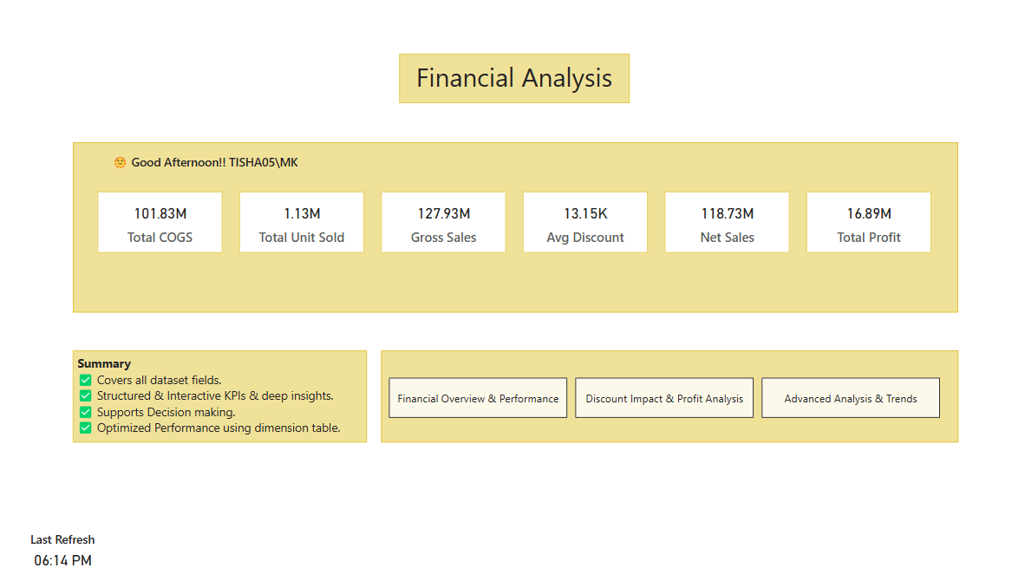

**Tools & Techniques**

* Power BI
* Power Query
* DAX
* Data Modelling
* Data Visualization

**How to Use**

1. Clone this repository
2. Download the .pbix file.
3. Open with Power BI Desktop
4. Replace the sample data with your own (if applicable).
5. Explore Insights!

**Author**

**Name:** Tisha Gupta

**Linked IN:** [www.linkedin.com/in/tisha-gupta-3034b222b](http://www.linkedin.com/in/tisha-gupta-3034b222b)

**Email:** [tishagupta994@gmail.com](mailto:tishagupta994@gmail.com)